How does the density of bike-sharing systems and usage vary across different metropolitan areas in the United States?
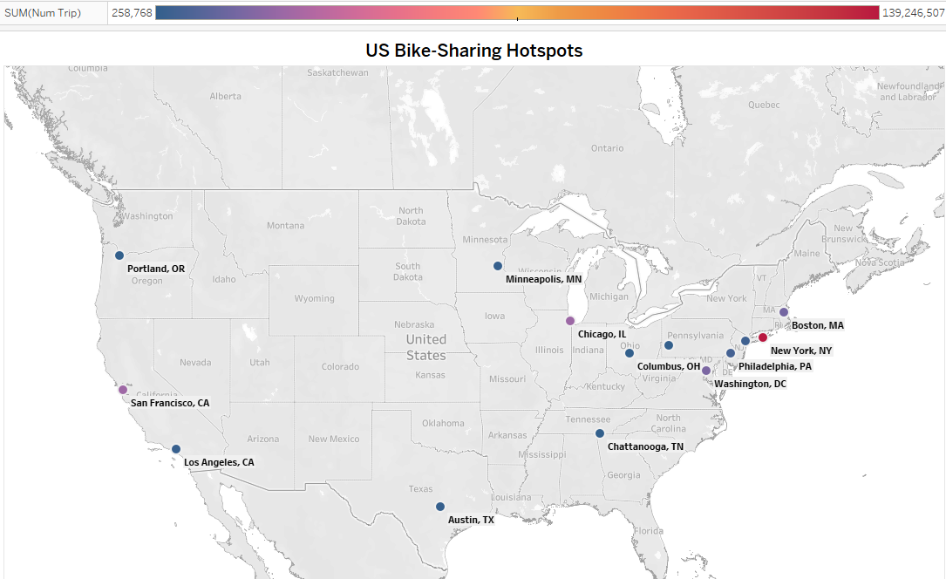
Bike-sharing systems and usage vary significantly across US cities. Major metropolitan areas like New York, Boston, Chicago, and San Francisco have high densities of systems and heavy usage, likely due to factors such as population density, public transportation infrastructure, and bike-friendly culture. Cities like Philadelphia, Washington D.C., and Minneapolis also have notable bike-sharing programs, but their usage tends to be lower. In contrast, cities in the Midwest and South generally have lower bike-sharing density and usage.

Is there a significant difference in the average trip duration between the four seasons (Winter, Spring, Summer, and Fall)? 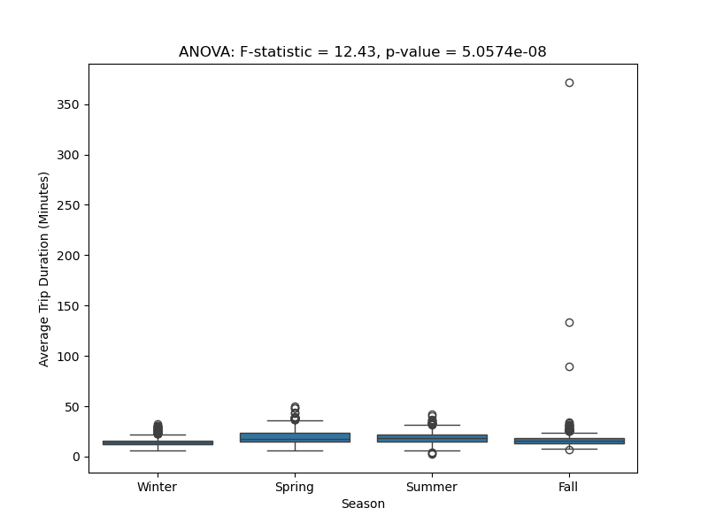

The analysis reveals significant seasonal variations in bike-sharing trip durations. The ANOVA test confirms these differences are statistically significant with a very small p-value (p < 0.05 and p< 0.001) and a large F-statistic Shorter winter trips, likely due to colder weather and fewer daylight hours, contrast with longer spring, summer, and fall trips, which may be attributed to increased outdoor activities, tourism, and more favorable weather conditions. The significant difference in trip durations between seasons, as evidenced by the ANOVA results, must also be viewed in the context of the data spanning 2019-2023. This period includes seasons impacted by the COVID-19 pandemic, which saw drastically reduced ridership during colder winters, skewing the data and contributing to the observed differences. Such anomalies highlight the need to interpret the findings with consideration for these external factors, which may have disproportionately affected the winter data.

How did the COVID-19 pandemic impact bike-sharing usage patterns in different cities and regions?
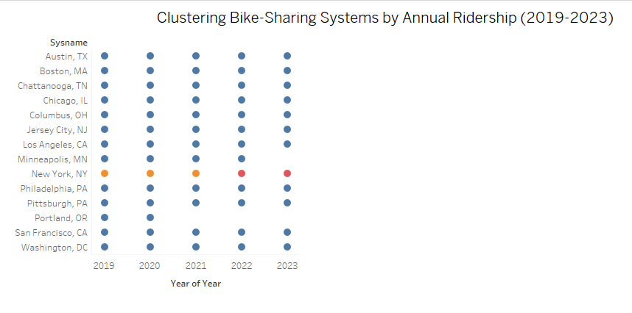
The K-means clustering analysis reveals distinct groups of bike-sharing systems based on annual ridership. Cities like New York, Boston, and Chicago form a high-ridership cluster, demonstrating strong and resilient bike-sharing cultures. Cities like Philadelphia, Washington D.C., and San Francisco fall into a medium-ridership cluster. Lower-ridership cities, such as Austin, Chattanooga, and Pittsburgh, may have factors limiting their usage, such as lower population density or less developed bike infrastructure.
The impact of the COVID-19 pandemic is evident in the data, with some cities experiencing significant fluctuations in ridership. For instance, cities with high pre-pandemic ridership, such as New York, might have experienced a temporary decline due to lockdowns and remote work, but have since recovered. On the other hand, cities with lower ridership or those heavily reliant on motor vehicles may have struggled to recover, especially in areas with less dense urban environments like Portland, Oregon.

